Shopping Project Task
Developer 1 : G.Shruthi(23B81A05A7)
Developer 2: P.Nandhika(23B81A0587)
Developer 1: (Part – A)
I created a repo in GitHub and added developer2 as a collaborator, giving all required access permissions.
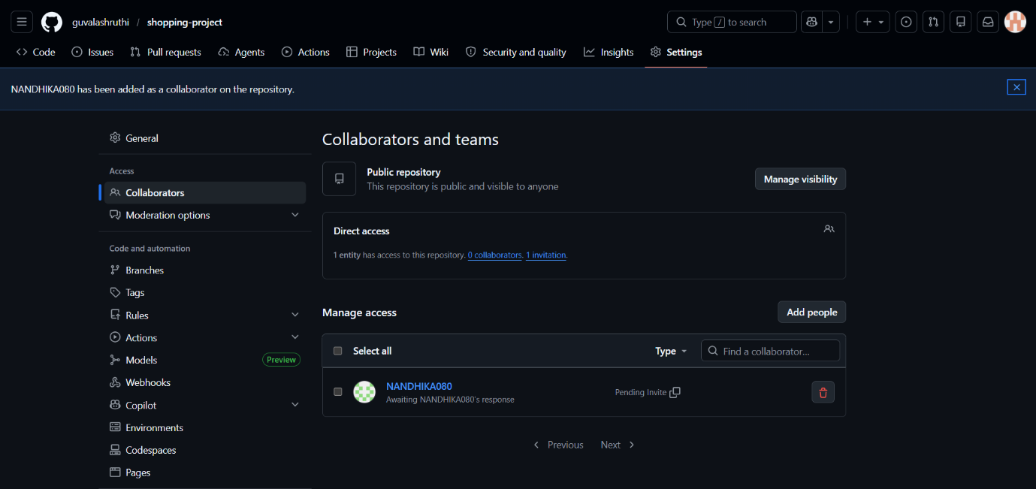
I cloned the repo and added products.txt and orders.txt files, and pushed them into the repository.
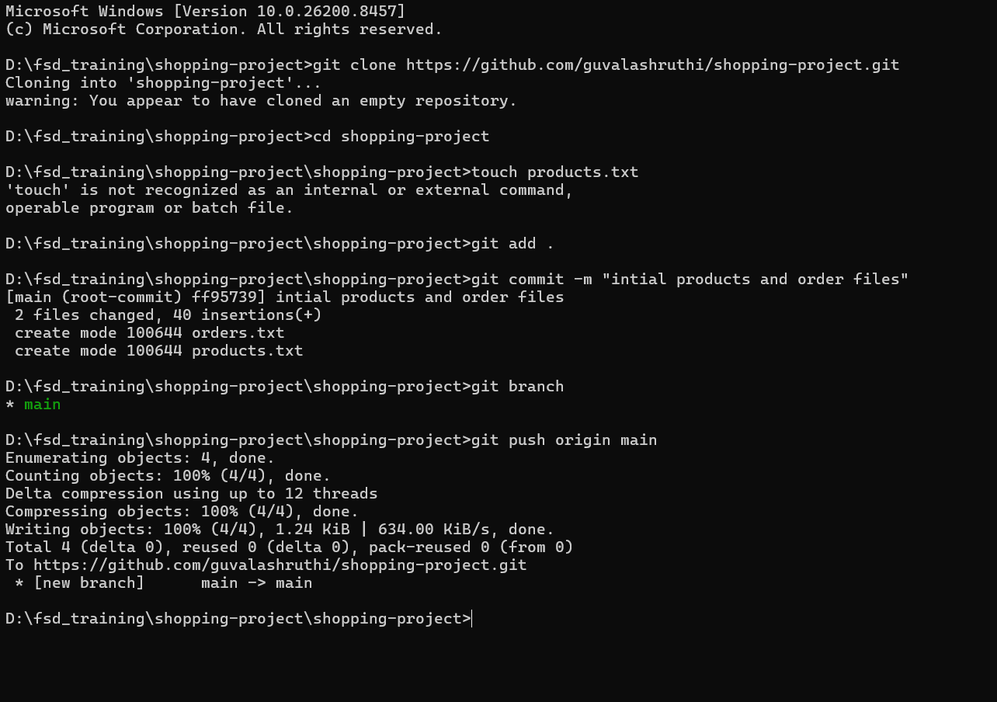
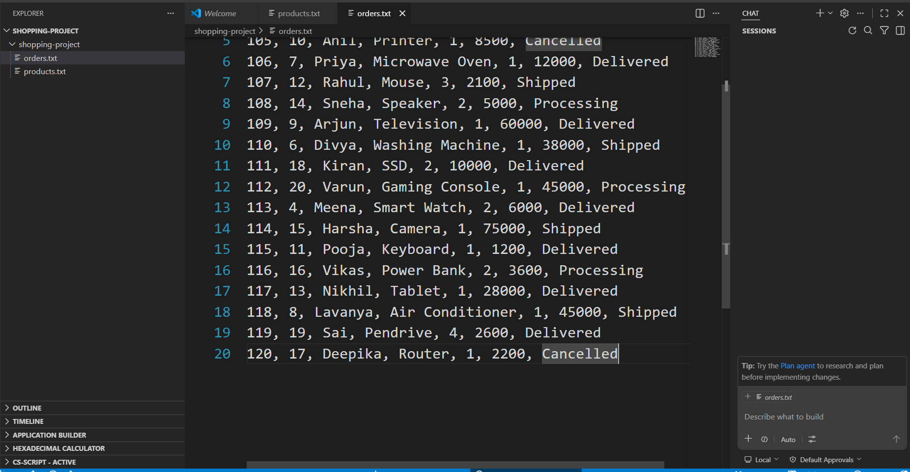
Developer 2 (part b):
Cloned the product.txt and order.txt files from the remote repository to the local system.
Created a branch add-products and committed the products.txt
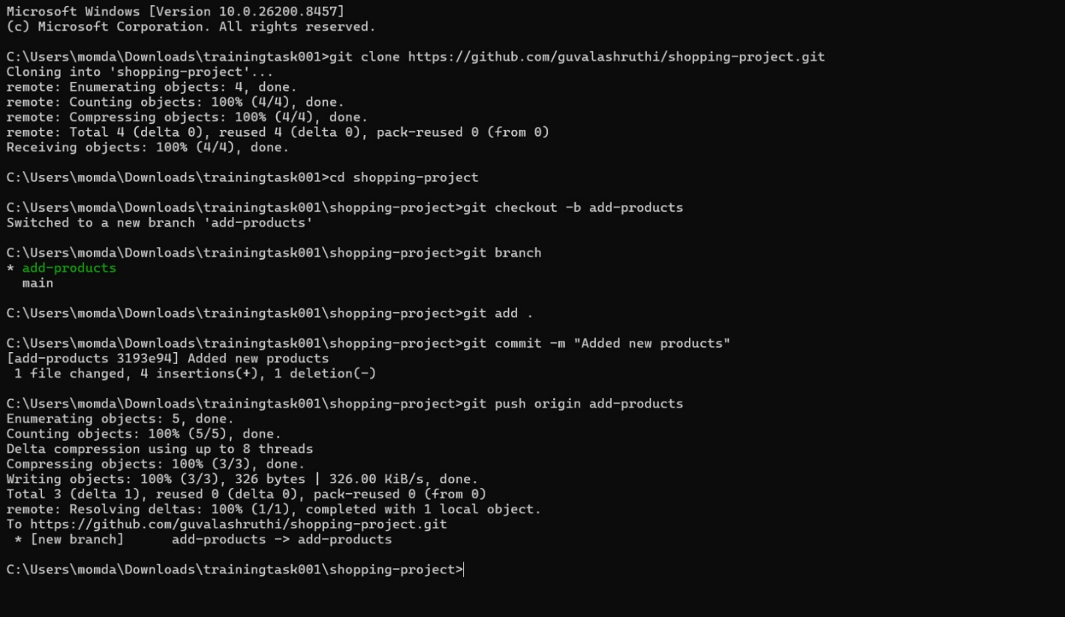
Then created the pull request, and Developer 1 accepted the changes and merged.
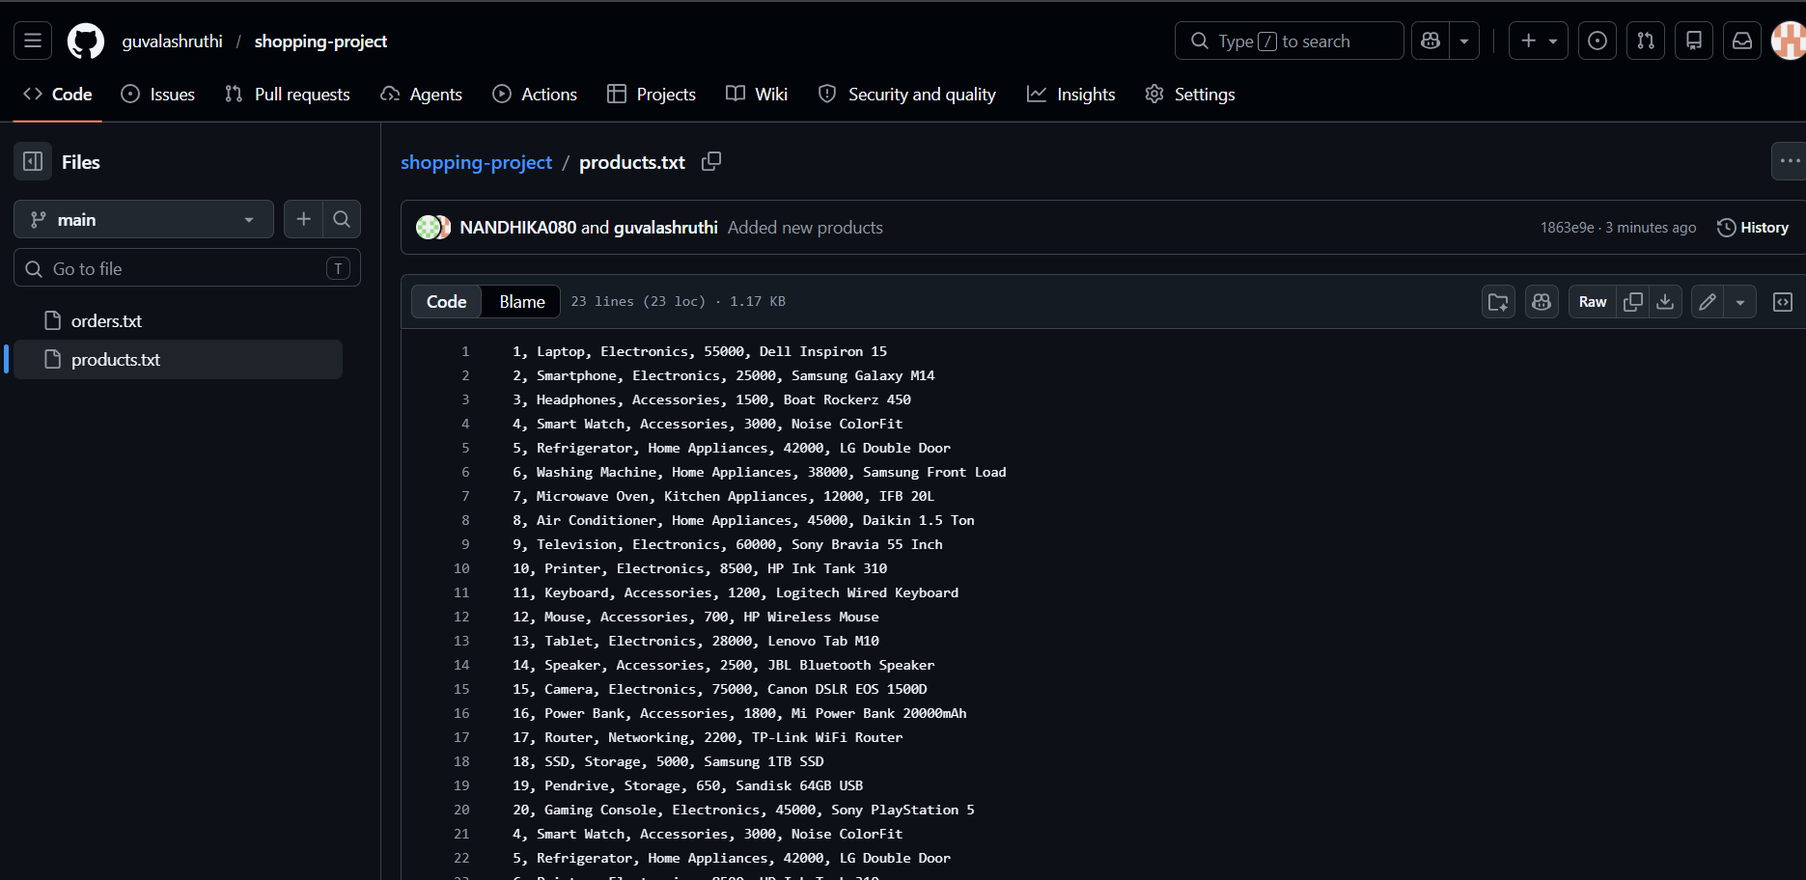
Then creates the another branch update-orders and updated the file orders.txt and pushed it . created pull request. And developer 1 merged it.
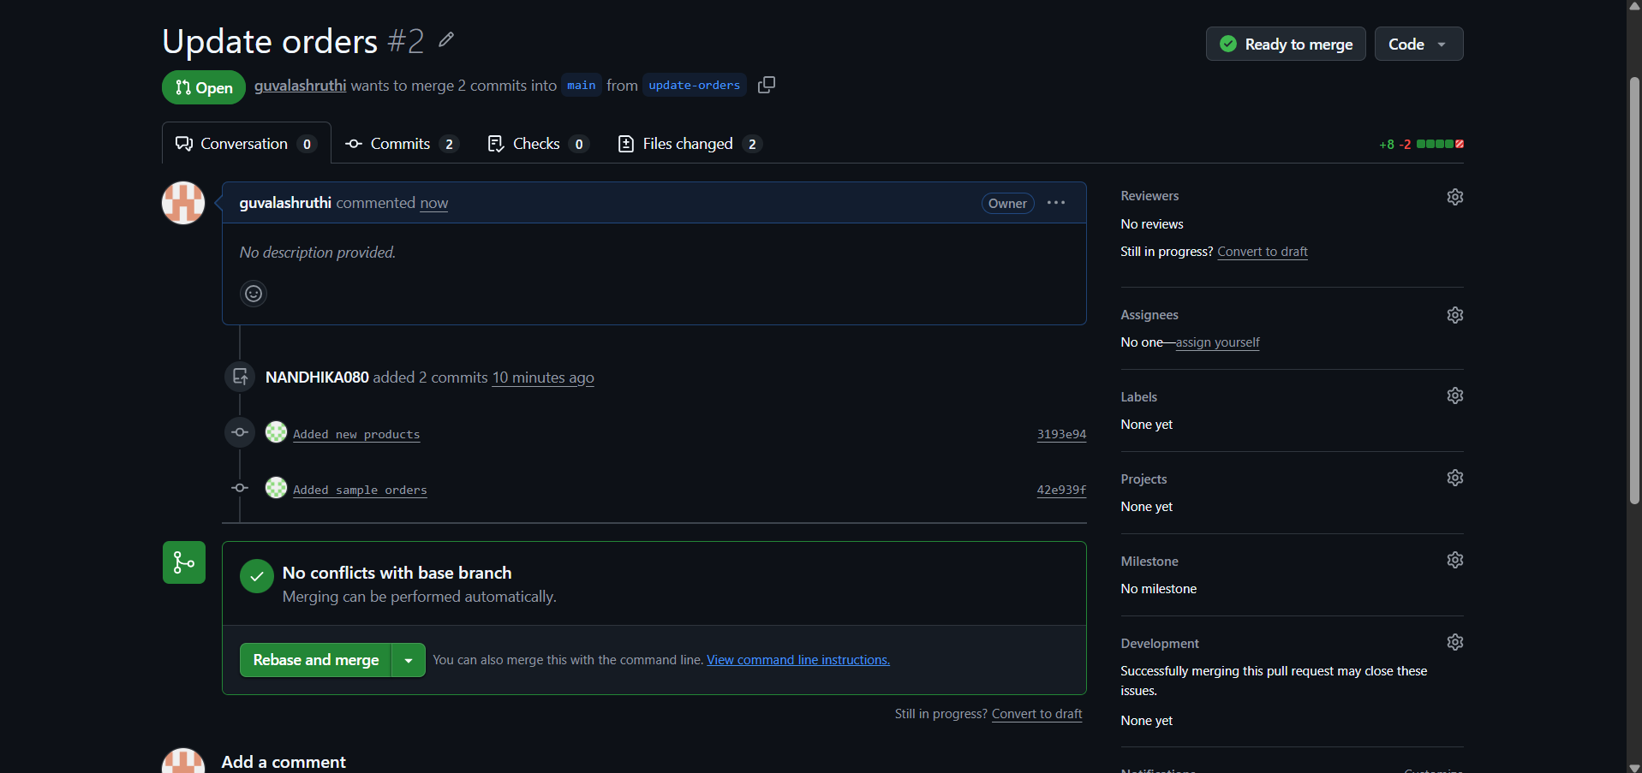
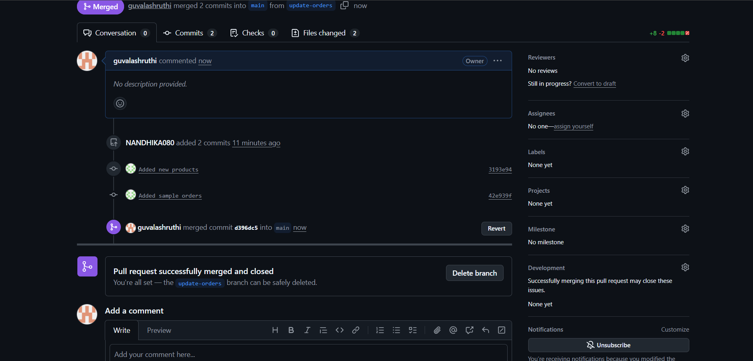
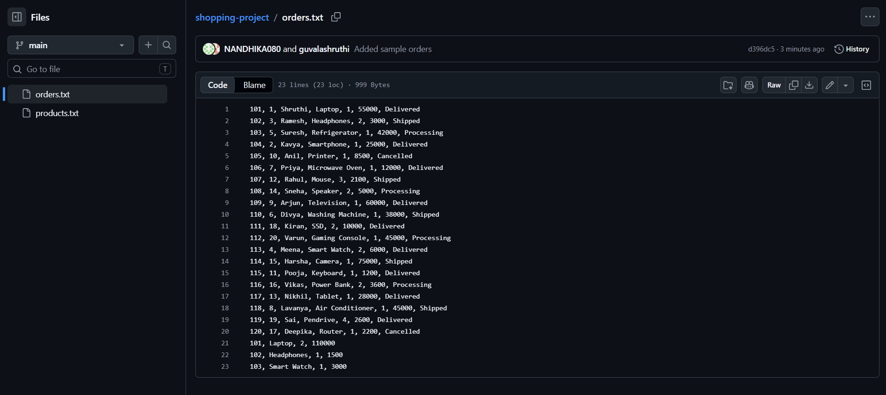
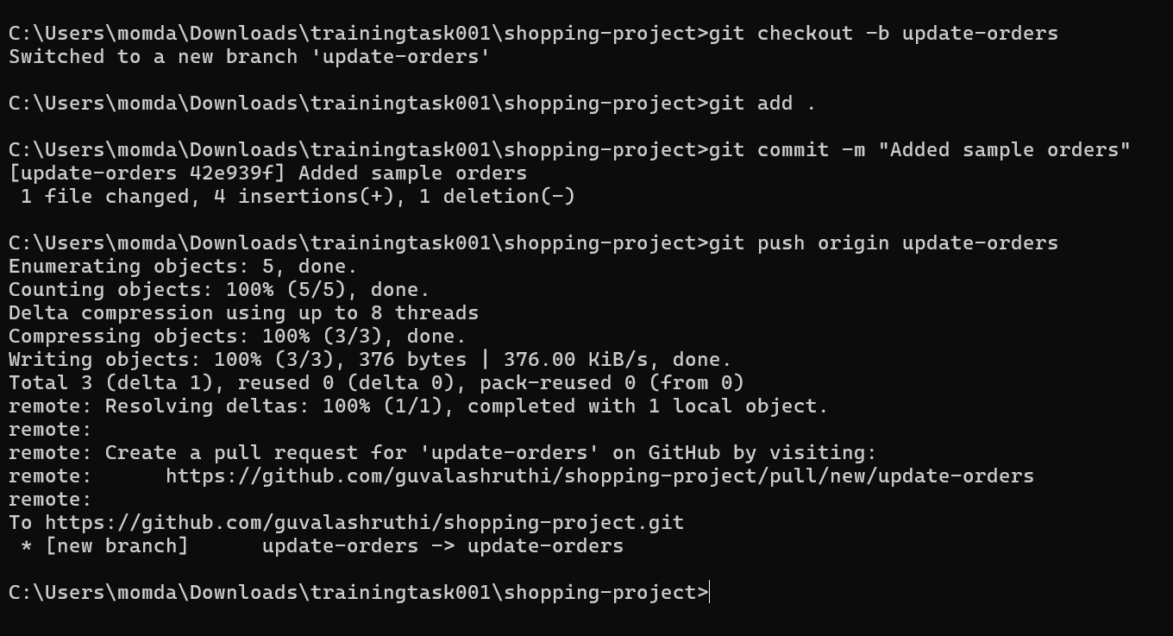
Developer1 (part -d):
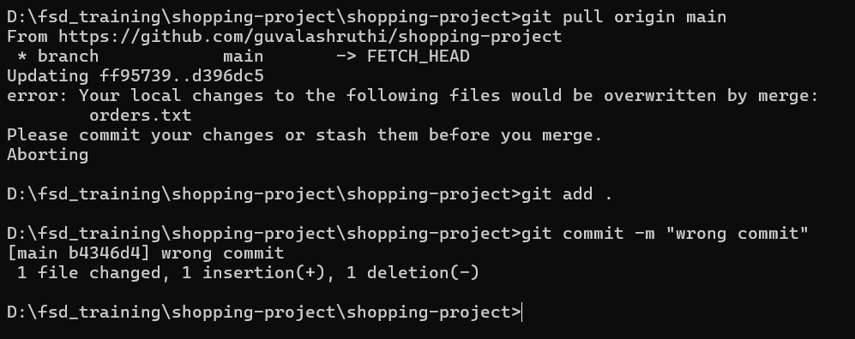
I reset the wrong commit and added the correct data in product.txt and commit it
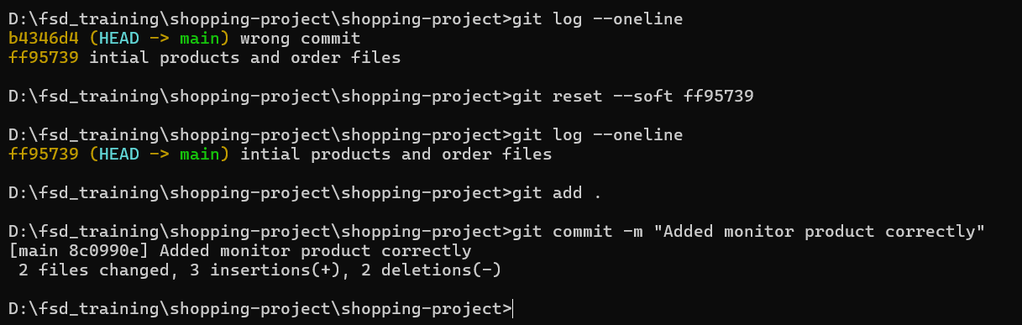
Revert
